PROGRAM SCHEDULE
Thursday, August 4th, 2022
Morning Sessions
7:45am - | 8:15am | Continental Breakfast
8:15am - | 8:30am | Welcome Remarks: Alexandros Makriyannis  Provost David Madigan
8:30am - |  | Session 1: Presider Marcus Tius
8:30am - | 9:00am | Dr. Laura Bohn  University of Florida Scripps  Modulating Opioid Receptors to Improve Therapeutic Potential
9:00am - | 9:30am | Dr. Yan Zhang  Virginia Commonwealth University  Development of Mu Opioid Receptor Selective Modulators as Novel Therapeutics for Opioid Use Disorders
9:30am - | 10:00am | Dr. Andrew Huhn  Johns Hopkins University  Randomized-Controlled Trial of Suvorexant to Treat Sleep Disturbance, Opioid Withdrawal, and Craving in Persons with Opioid Use Disorder
10:00am - | 10:30am | Markos Georgiadis  Center for Drug Discovery, Northeastern University  Novel Potent and Metabolically Stable Endocannabinoid Ligands
10:30am - | 10:50am | Coffee Break
10:50am - |  | Session 2: Presider Hideaki Yano
10:50am - | 11:30pm | Keynote Address  Dr. Seva Katritch  University of Southern California  From Giga-Scale Screening to Functionalization of Known Scaffolds: How Structure-Based Computations Enable Discovery of New Leads for Addiction Disorders
11:30pm - | 12:00pm | Dr. Daniel Rosenbaum  University of Texas  Ligand Binding and Modulation of the CB1 Receptor
12:00pm - | 12:30pm | Dr. Andrea Hohman  Indiana University Bloomington  Sparing of Morphine Tolerance in a Mouse Model of Anti-Retroviral Induced Neuropathic Pain
12:30pm - | 12:50pm | Dr. Hideaki Yano  Northeastern University  Molecular Mechanisms of Superagonism Elicited by Synthetic Cannabinoid Actions on CB1 Receptors
12:50pm - | 1:02pm | Dr. Madelyn Ray  Boston University  Cell-type Specific Transcriptional Signatures Associated with Opioid Use Disorder Using Single Nuclei RNA-Seq of Human Postmortem Brain

PROGRAM SCHEDULE
Thursday, August 4th, 2022
Afternoon Sessions
1:02pm - | 2:00pm | Lunch
2:00pm - |  | Session 3: Presider Andrea Hohman
2:00pm - | 2:40pm | Dr. Bryan Roth  University of North Carolina, Chapel Hill  Structure, Function and Pharmacology of MRGPRX-Family Receptors
2:40pm - | 3:10pm | Dr. Takashi Tsukamoto  Johns Hopkins University  Positive Allosteric Modulators of Human MAS-Related G Protein-Coupled Receptor X1 (MRGPRX1) for the Treatment of Neuropathic Pain
3:10pm - | 3:30pm | Dr. Venetia Zachariou  Icahn School of Medicine at Mount Sinai  SARS-CoV-2 Airway Infection Results in Time-dependent Sensory Abnormalities in a Hamster Model
3:30pm - | 3:50pm | Dr. Tristan McClure-Begley  NIDA (DNB)  Overview of Branch Directives, Research Priorities and Interests
3:50pm - | 4:10pm | Coffee Break
4:10pm - |  | Session 4: Presider Imad Damaj
4:10pm - | 4:40pm | Dr. Steven Negus  Virginia Commonwealth University  Drug-Choice Procedures for Assessment of Candidate Medications to Treat Opioid Use Disorder
4:40pm - | 5:10pm | Dr. Lipin Ji/ Dr. Anna Sromek  MAKScientific/Northeastern University  CB1 Neutral Antagonists as an Effective Approach for Treating Substance Use Disorders
5:10pm - | 5:22pm | Kimberly Karin  Virginia Commonwealth University  Oleoyl Glycine and its Methylated Analogue, Oleoyl Alanine, Reduce Nicotine Seeking in Rats
5:22pm - | 5:34pm | Emily Burke  McLean Hospital/Harvard Medical School  Fentanyl-Targeting Monoclonal Antibodies Block Fentanyl-Induced Respiratory Depression

PROGRAM SCHEDULE
Thursday, August 4th, 2022
Evening Program

5:30pm - | 6:00pm | Business Meeting (Closed session)
This is a closed meeting for members of the CPDA Advisory Board

6:00pm- | 8:30pm | Poster Abstract Showcase and Reception  Raytheon Amphitheatre & Cabral Center
The Raytheon Amphitheatre and Cabral Center will be open for presenters to set up their posters after 5:00pm. Please have your poster up by 6:30 pm
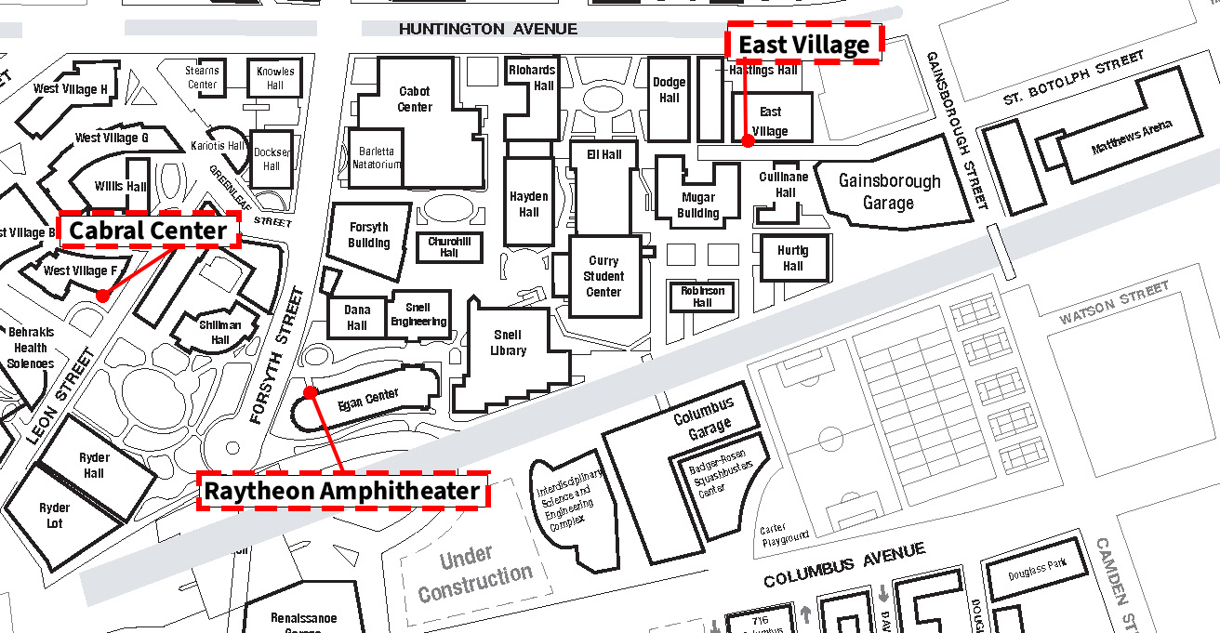

PROGRAM SCHEDULE
Friday, August 5th, 2022
Morning Sessions

7:45am - |  | 8:20am | Continental Breakfast
8:20am - |  | 8:30am | Welcome Remarks: Alexandros Makriyannis  Dean Carmen Sceppa
 |  |  | Session 5: Presider Laura Bohn
8:30am - |  | 9:00am | Dr. Yiorgo Skiniotis  Stanford University  Structural Insights into Distinct Signaling Profiles by mu-Opioid Receptor Agonists
9:00am - | 9:30am |  | Dr. Gregory Dudley  West Virginia University  Benzannulation Chemistry for the Synthesis of Pharmacologically Active Compounds
9:30am - | 10:00am |  | Dr. Christos Iliopoulos  Center for Drug Discovery, Northeastern University  Structural Insights into Cannabinoid Receptors Drug Discovery
10:00am - |  | 10:20am | Dr. Christoph Gorgulla  Harvard Medical School  Drug Discovery Platform for the Rapid Discovery of Potent Drug Candidates for Addiction Related Target Proteins
10:20am - |  | 10:32am | Ryan McGlynn  Center for Drug Discovery, Northeastern University  Development of 5HT1 Receptor Ligands for Substance Use Disorder Withdrawal
10:32am - |  | 10:52am | Coffee Break
10:52am - | 10:55am |  | Session 6: Presider Raymond Booth
10:55am - |  | 11:35am | Dr. David E. Nichols  University of North Carolina, Chapel Hill  Brief Overview of Psychedelics, from Natural Sources to Receptors
11:35pm - |  | 12:05pm | Dr. Albert Garcia Romeu  Johns Hopkins University  Psychedelic Therapeutics Re-Examined: State of the Science
12:05pm - |  | 12:25pm | Dr. Mahmoud Nasr  Harvard Medical School  Engineering Modular Protein Biosensors for the Rapid Detection of Viruses
12:25pm - |  | 12:37pm | Dr. Balazs Varga  Washington University  Structure Based Design of Delta Opioid Receptor Bitopic Agonist Analgesics Targeting the Sodium Site
12:37pm - |  | 12:49pm | Dr. Jenny Wilkerson  Texas Tech University Health Sciences Center  The Kratom Alkaloid Mitragynine Decreases Remifentanil Self-Administration and Attenuates Naltrexone-induced Morphine Withdrawal in Rats

PROGRAM SCHEDULE
Friday, August 5th, 2022
Afternoon Sessions

12:49pm - | 1:01pm | Dr. Gisela Andrea Camacho Hernandez  NIDA/IRP  Illuminating the Monoamine Transporters: High Affinity Fluorescent Probes for Selective Visualization of DAT and NET
1:01pm- | 2:00pm | Lunch
2:00pm - |  | Session 7 : Presider Christos Iliopoulos Tsoutsouvas
2:00pm - | 2:30pm | Dr. Imad Damaj  Virginia Commonwealth University  Alpha7 Nicotinic Acetylcholine Receptors as a Target for the Treatment of Neuropathic Pain
2:30pm - | 2:50pm | Dr. Dai Lu  Texas A&M  The Challenges of Developing Allosteric Modulators of the CB1 Receptor
2:50pm - | 3:02pm | Kelly Wingfield  Boston University  Behavioral Differences in Neonatal Opioid Withdrawal Syndrome (NOWS) Model Traits in FVB Substrains Following Perinatal Morphine Exposure
3:02pm - | 3:14pm | Bryan Mckiver  Virginia Commonwealth University  Astrocyte Elevated Gene-1 (AEG-1) Deletion Selectively Enhances the Antinociceptive Effects of Morphine
3:14pm - | 3:35pm | Coffee Break
3:35pm - |  | Session 8: Presider Carol Paronis
3:35pm - | 3:55pm | Dr. Stephen Kohut  McLean Hospital  Neural Consequences of Adolescent Cannabinoid Exposure in Nonhuman Primates
3:55pm- | 4:25pm | Dr Scott Lukas  McLean Hospital  Developing and Testing Novel Passive Breath Analysis Devices for Alcohol and THC
4:25pm - | 4:35 pm | Closing Remarks

